Effect of salinity on growth and yield of selected tomato (Solanum lycopersicum L.) hybrids grown in Anauradhapura, Sri Lanka

Giriraj patabendige dilan perera

MSc/MPhil/PhD Thesis

January 2022
Effect of salinity on growth and yield of selected tomato (Solanum lycopersicum L.) hybrids grown in Anauradhapura, Sri Lanka

Giriraj patabendige dilan perera

January 2022
Certification of Supervisors
This is to certify that this thesis on the ‘Effect of salinity on growth and yield of selected tomato (Solanum lycopersicum L.) hybrids grown in Anauradhapura, Sri Lanka’ is completed by Giriraj Patabendige Dilan Perera in partial fulfillment of the requirements for the degree of Master / Doctor of Philosophy in qualifier here. This thesis has been carried out under my/ our guidance.

Signature :
Supervisor's full name :
Official Address :
Date :

Declaration by the Candidate and Copyright Information
I hereby do solemnly declare that the work presented in this thesis describes the results of my own independent research except where due references have been cited within text. No part of this thesis has been submitted previously or concurrently to any other University/ College/ Organization for an academic qualification/ certificate/ diploma or degree.

The work I have presented does not breach any copyright regulation.

Signature :
Student's full name :
Address :
Date :

Acknowledgement
Candidate may wish to acknowledge valuable contributions from their research supervisors, funding agencies, relatives, friends and colleagues as well as the University. The acknowledgements shall appear on the page immediately following the page for declaration and copyright information. Avoid acknowledging people without mentioning the reasons for being acknowledged.
Abstract
This section should summarize the content of the entire thesis and the way in which the work was executed, describe the scope of the work, research methods used, the main sections of the work and the conclusions reached. The abstract should not exceed 500 words and should not have any bibliographic information, figures or tables and be printed with 1.5 line spacing. Number of keywords is limited to five (05). They should select in addition to the words already mentioned in the title, and sorted alphabetically.
Keywords:

Table of Contents
Table of Contents ii
List of Tables iii
List of Figures iv
List of Illustrations v
List of Abbreviations vi
Chapter One 1
General Introduction 1
Chapter Two 2
Literature Review 2
2.1. Global market trends 2
Tomato production statistics in Sri Lanka 2
Chapter Three 3
Manuscript-based chapters - Hybrid tomato cultivars do not tolerate mild water stress in reddish brown earth soils 3
3.1. Abstract 3
3.2. Introduction 4
3.3. Materials and Methods 4
3.4. Results and Discussion 4
3.5. Conclusion 6
Chapter Four 7
General Conclusions and Recommendations 7
References and Bibliography 8
Appendices 11
List of Publications 12

List of Tables
Table 1. Average yield statistics tomato varieties grown in Galenbindunuwewa GN Division, Anuradhapura, Sri Lanka during 2020-2021 period 5

List of Figures
Figure 1. Dry weight of mature fruits and dry weight of leaves as predicted by an integrated yield prediction model for field grown tomato in Anuradhapura, Sri Lanka 5

List of Illustrations
Illustration 1. Components of a tomato flower and a fruit 6

List of Abbreviations
PhD : Doctor of Philosophy
MPhil : Master of Philosophy
FoA : Faculty of Agriculture
RUSL : Rajarata University of Sri Lanka

Chapter One
General Introduction
It introduces your work to the reader (Waterman et al., 1993). This section should be based on the introduction of all manuscript-based chapters presented in the rest of the thesis. Main elements to be discuss under this section are: Topic and context - should give a general understanding related to the topic and context, Focus and scope - should discuss about the area that focusses the research work, Relevance and importance - should justify the importance of the research work, Research problem, hypotheses, and objectives – should elaborate on research problem, hypotheses proposed, general and specific objectives (Mathes & Severa, 2004).

Chapter Two
Literature Review
2.1. Global market trends
Literature review provides a critical assessment of the information so far published and gives background information to the research problem that is proposed to be addressed. Further, it will help to identify the gap between present state of the knowledge and the research that is attempted to address.
Tomato production statistics in Sri Lanka

Chapter Three
Manuscript-based chapters - Hybrid tomato cultivars do not tolerate mild water stress in reddish brown earth soils
3.1. Abstract
There can be a minimum of two manuscript-based chapters for MPhil and three of them for the PhD. Each of these manuscript-based chapters should consists of following main sections: abstract, introduction, materials and methods, results and discussion, and conclusion. Note that the list of references should be given at the end of the thesis for all the chapters. The topic of the chapter should be typed following the formatting guidelines appropriate for ‘main heading’ given in Table 1. Each abstract of manuscript-based chapters should focus on particular research that is being presented in the chapter. The length should be between 200 – 300 words. Number of keywords is limited to five (05). They should selecte in in addition to the words already mentioned in the title, and sorted alphabetically. The main text should follow the appropriate formatting guidelines given in Table 1. Each abstract of manuscript-based chapters should focus on particular research that is being presented in the chapter. The length should be between 200 – 300 words. Number of keywords is limited to five (05). They should be selected in addition to the words already mentioned in the title, and sorted alphabetically. The main text should follow the appropriate formatting guidelines given in Table 1.
Keywords:

3.2. Introduction
Introduction of each manuscript-based chapter should present the background into the research problem being answered in the particular chapter. This should be logically organized following the scientific method. The hypotheses/objectives of the works should be eventually stated in the final section of the introduction. The main text should follow the appropriate formatting guidelines given in Table 1.

3.3. Materials and Methods
This section should provide enough details so that another person can repeat, verify or continue from where the current work is stopped. Experiments should be always described in a logical order. Generally, adequate description of the site/s where the study is conducted, experimental design/s, and how the data were collected. A detailed description on how the data were anlaysed should be given including the choice of appropriate statistical analytical method/s, number of replicates and sampling frame, mean separation and model evaluation procedures, software and statistical packages invoked. If you have used a well-known method just give the name and reference. When using a new or original method or revised method it should be described in detail. Always give important information like; sizes, volumes, centrifugation speed, temperatures, and equipment used. When special laboratory equipment, assay kits are used the model, make and country of origin should be indicated as appropriate. The main text of this section should follow the appropriate formatting guidelines given in Table 1.
$x=\frac{-b±\sqrt{b^{2}-4ac}}{2a}$ …………………………………………………....... Equation 1

3.4. Results and Discussion
Results should describe clearly the findings of the study. Only the relevant results should be presented in the section in accordance with the research problem/s investigated or hypotheses/objectives evaluated. The discussion shows how the results and interpretations agree/disagree with previously published work. If they do not agree with the study, explain possible reasons for the difference found.
Table 1. Average yield statistics tomato varieties grown in Galenbindunuwewa GN Division, Anuradhapura, Sri Lanka during 2020-2021 period
Variety | Total area (ha) | Average yield (‘000 kg ha⁻¹)
Maheshi | 20 | 35.08 ± 2.34
Bhathiya | 32 | 55.78 ± 5.54
T-245 | 14 | 17.25 ± 4.33

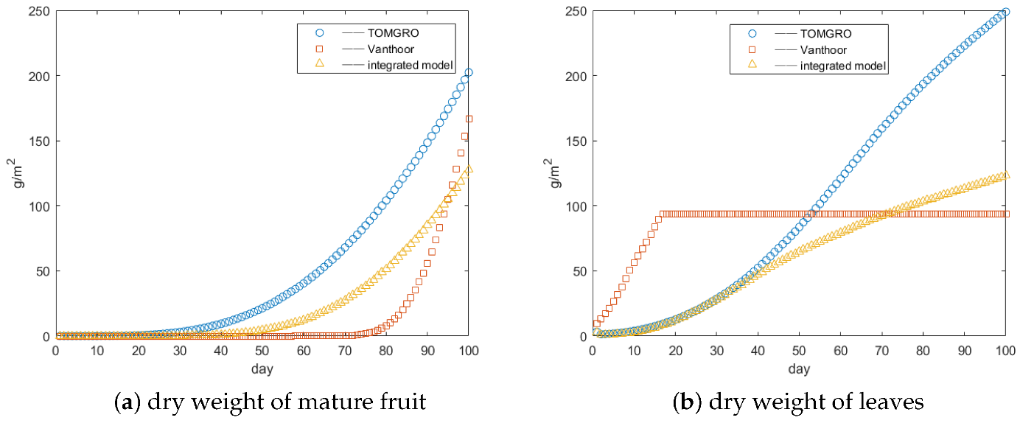
Figure 1. Dry weight of mature fruits and dry weight of leaves as predicted by an integrated yield prediction model for field grown tomato in Anuradhapura, Sri Lanka
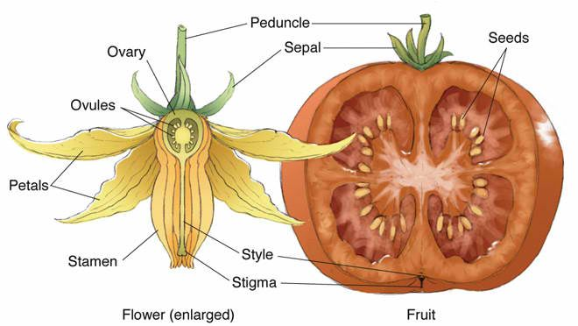
Illustration 1. Components of a tomato flower and a fruit
3.5. Conclusion
Conclusion should not repeat what you have said in the discussion. Conclusion should address the research problem and provide answers to the objectives. The text formatting should follow the appropriate formatting guidelines given in Table 1.

Chapter Four
General Conclusions and Recommendations
A general conclusion should be drawn based on the overall aim of the thesis and the appropriate connections should be made to the independent manuscript-based chapters presented. The text formatting should follow the appropriate main text formatting guidelines given in Table 1.

References and Bibliography
Use a Reference Manager and Citation Software for populating citations and the list of references. One reference style should be followed for the entire thesis. The list of references for the entire thesis should only be presented in this setion.

It is strongly recommended to use the Mendeley Reference Manager for citations and adding the list of references which is available via https://www.mendeley.com.
Basic guidelines are available at https://www.mendeley.com/guides/using-citation-editor/04-citation-styles.
An exclusive citation style file ‘Postgraduate Programme, FOA, RUSL’ for Mendeley can be downloaded through Mendeley Desktop via http://csl.mendeley.com/styles/11037681/AgriRJT.
In-text citations should follow the author-date method (APA style) whereby the author’s last name and the year of publication for the source should appear in the text, for example, (Jones, 1998).
The complete reference list should appear alphabetically by name at the end of the paper.
Please note that a DOI should be provided for all references where available.
You will not be asked to reformat references during proposal report or in the thesis, however, a sample of the most common entries in our reference lists appears below.

Within Text Citations
One author: Gabriel (2000) and (Gabriel, 2000)
Two authors: (Mathes & Severa, 2004) and Mathes and Severa (2004)
Three or more authors (first occurrence): Waterman et al. (1993) and (Waterman et al., 1993).
If two papers have first-listed authors with the same name in the reference list: To avoid ambiguity, list as many names as needed to differentiate the papers, followed by “et al.” in citations.
Fannon, Chan, Ramirez, Johnson, and Grimsdottir (2019) … and Fannon, Chan, Montego, Daniels, and Miller (2019)… can be cited as (Fannon, Chan, Ramirez, et al., 2019) or Fannon, Chan, Ramirez et al. (2019), and (Fannon, Chan, Montego, et al., 2019) or Fannon, Chan, Montego et al. (2019), respectively.
Personal communication citations are not included in the reference list. Cite personal communications in text only. Give the initials as well as the surname of the communicator, and provide as exact a date as possible.
References should be cited as ‘in press’ only if the paper has been accepted for publication. Work not yet submitted for publication or under review should be cited as ‘unpublished data’, with the author’s initials and surname given; such work should not be included in the Reference section. Any paper cited as ‘in press’ or under review elsewhere must be uploaded as part of the manuscript submission as a file ‘not for review’ so that it can be seen by the editors and, if necessary, made available to the referees.

In Reference List
Journal article
DOIs are formatted the same as URLs. The label “DOI:” is not necessary.
Surnames and initials for up to 20 authors should be provided in the reference list.
Beers, S. R. , & De Bellis, M. D. (2002). Neuropsychological function in children with maltreatment-related posttraumatic stress disorder. The American Journal of Psychiatry, 159, 483–486. https://doi.org/10.1176/appi.ajp.159.3.483
Ramus, F., Rosen, S., Dakin, S. C., Day, B. L., Castellote, J. M., White, S., & Frith, U. (2003). Theories of developmental dyslexia: Insights from a multiple case study of dyslexic adults. Brain, 126(4), 841–865. https://doi.org/10.1093/brain/awg076

Book edition
The publisher location is not included in the reference.
Bradley-Johnson, S. (1994). Psychoeducational assessment of students who are visually impaired or blind: Infancy through high school (2nd ed.). Pro-ed.
Edited book
Hawkley, L. C., Preacher, K. J., & Cacioppo, J. T. (2007). Multilevel modeling of social interactions and mood in lonely and socially connected individuals: The MacArthur social neuroscience studies. In A. D. Ong & M. Van Dulmen (Eds.), Oxford handbook of methods in positive psychology (pp. 559–575). Oxford University Press.
Data sets
For any data with a unique identifier the format should be as follows:
Prugh, L. & Golden, C. (2013). Data from: Does moonlight increase predation risk? Meta-analysis reveals divergent responses of nocturnal mammals to lunar cycles. Dryad Digital Repository, http://dx.doi.org/105061/dryad.tm723.
Olden, J. (2015). Integrating landscape connectivity and invasion vulnerability to guide offensive and defensive invasive species management. Figshare. https://dx.doi.org/10.6084/m9.figshare.1285847.v2
Citations from web pages:
Authors may sometimes wish to cite information available from the internet in similar ways to the citation of published literature. In using this option, authors are asked to ensure that:
fully authenticated addresses are included in the reference list, along with titles, years and authors of the sources being cited;
the sites or information sources have sufficient longevity and ease of access for others to follow up the citation;
the information is of a scientific quality at least equal to that of peer-reviewed information available in learned scientific journals;
hard literature sources are used in preference where they are available.
It is likely that official web sites from organisations such as learned societies, government bodies or reputable NGOs will most often satisfy quality criteria.

Appendices
This contain useful information to the reader, which is related to the text but cannot be included in the text, such information can include tables too detailed for text presentations, technical notes on methods, interview schedules, questionnaires and case studies too long to be put in the text.

List of Publications
Give the bibliographic information of the complete list of publications made as outcome of the present study.

EFFECT OF SALINITY ON GROWTH AND YIELD OF TOMATO G.P.L. Perera PhD/MPhil/MSc Thesis 2022
Spine of the Hardbound Thesis
This should carry a shortened version of the title not exceeding 75 characters including spaces, name with initials, Thesis type, year of completion. Formatting should read from bottom to top, font size 12, upper case letters, center aligned.

